RESULTS:-
- Smart Home Automation System Using Intelligent Agents

INPUT :-
Is motion detected? (yes/no): yes
Enter room temperature (°C): 32
Is it Day or Night? Night

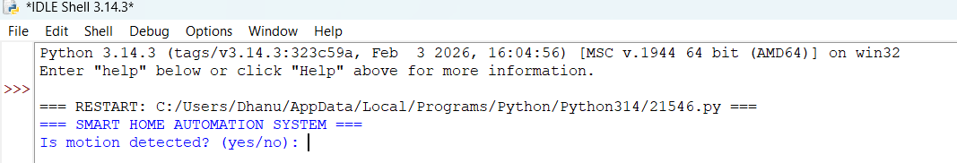
OUTPUT:-

2a)
INPUT :-
Is motion detected? (yes/no): no
Enter room temperature (°C): 18
Is it Day or Night? Day
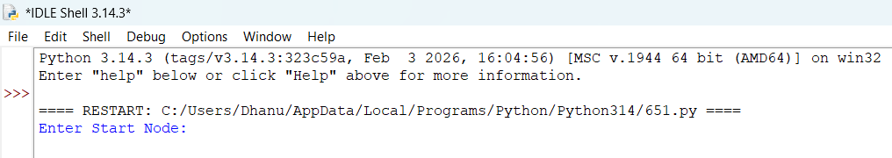
OUTPUT :-

2b)
Input:-
Enter Start Node: A
Enter Goal Node: G
Output: 

